DataCollectionsAutofill - Code Source

1-DataCollectionsAutofill - Ai Question - id 6
# Source: Person Source: Provided by: [Data Path: Persons Table -> ID Column: 1, Name_En Column: Motasem Essam] Written by: [Data Path: Persons Table -> ID Column: 1, Name_En Column: Motasem Essam] on [11/22/2025]
- Create python program to Auto Fill Data Collections File which choose folder that have tables access file
- then get data path for each table determine Folder name, Database name, Table name, Rows number and Columns number and rewrite them in in docs file like that
Data Path: Folder name-> Database name -> Table name [Rows x Columns: Rows number x Columns number]
- make file saved is Data Collections.docx
- make only one heading of each folder have all tables inside it
- make heading order same order of folders name
- make Data Path and name of table and Rows x Columns bold
- make Data Path take only one line so adjust the font size
- add Data Collections at top of document with heading 1
- add to start Total Tables, Total Rows and Total Columns:
- if there are database need password make a window to write my password for any table to write password
- if last rows in table all column is empty except id don’t count it
- That row has:
- empty strings → ❌
- zeros → ❌
- no real data → ❌
So it fails all conditions and is excluded from the count ✅

2-DataCollectionsAutofill - Ai Answer - id 6
# Source: AI Source: Provided by: [Data Path: Persons Table -> ID Column: 1, Name_En Column: Motasem Essam] -> From: [ChatGPT] on [11/22/2025]
Got it! You want a Python program that will automatically scan a folder for Access database files, extract metadata about tables (folder name, database name, table name, row & column counts), and write a well-formatted Word document (Data Collections.docx) with totals, headings, bold formatting, and proper layout. You also want it to prompt for passwords if a database is password-protected.
Here’s a full solution using pyodbc for Access database connections and python-docx for Word document generation.

✅ Features implemented:
- Select a folder containing subfolders of Access databases.
- Extract Folder name → Database name → Table name → Rows × Columns.
- Handles password-protected databases with a prompt window.
- One heading per folder with all tables inside.
- Bold formatting for data paths and table info.
- Heading Data Collections at the top.
- Totals for tables, rows, columns.
- Adjust font size for data path to fit in one line.
- Folder order alphabetical.

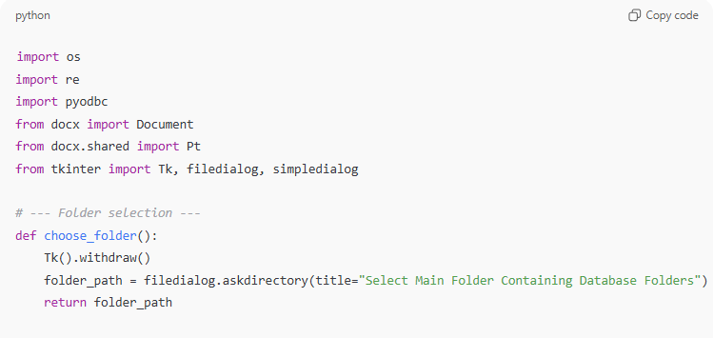
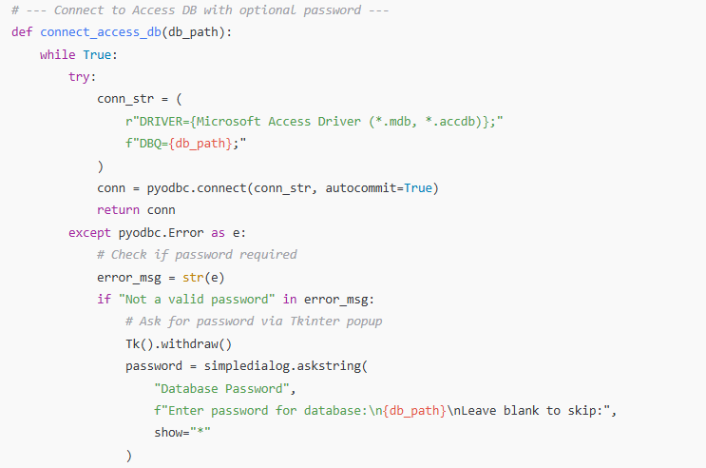
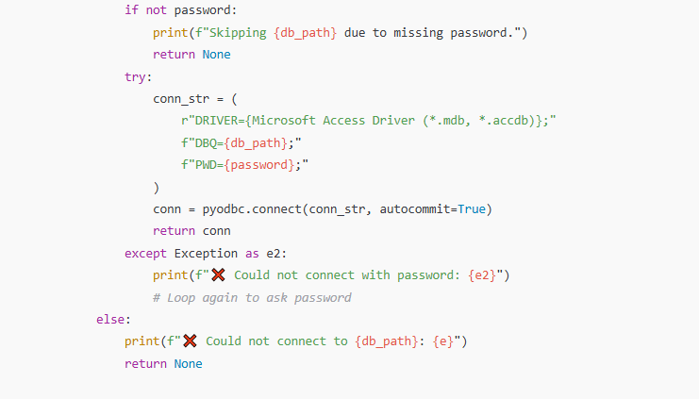
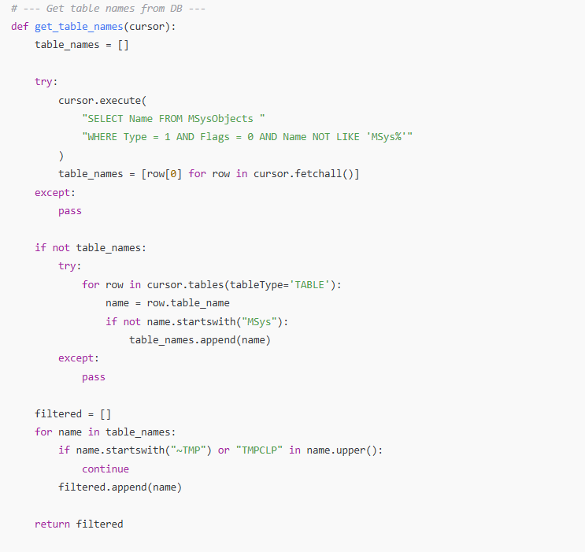
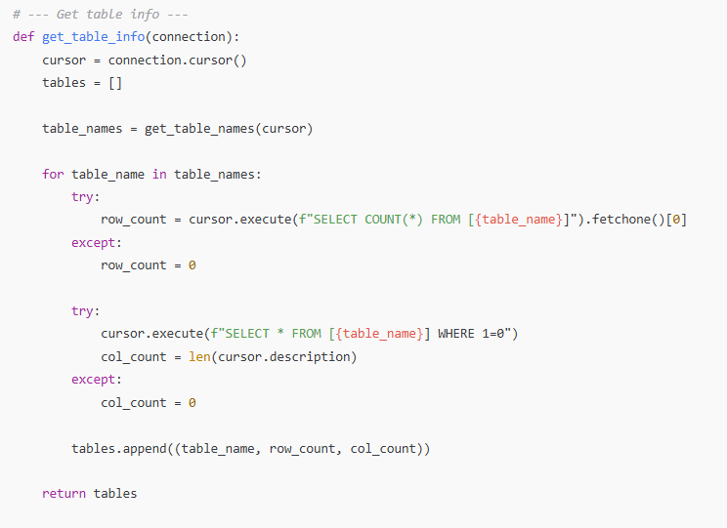
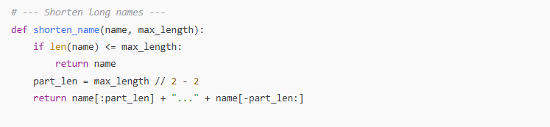
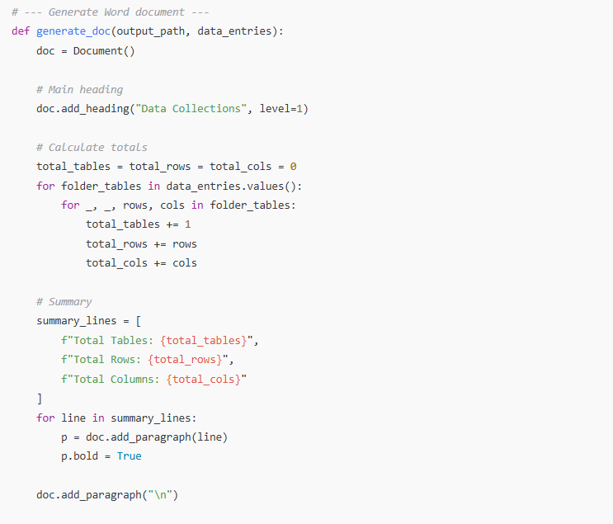
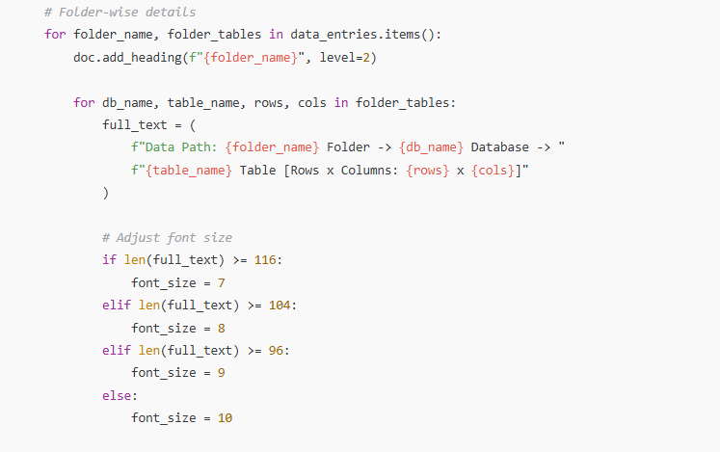
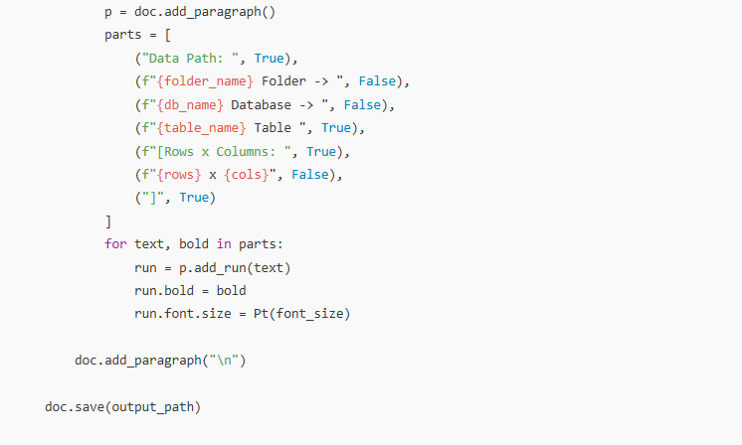
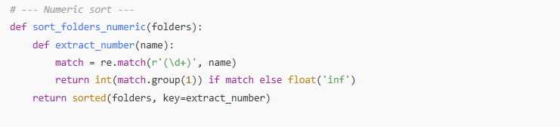
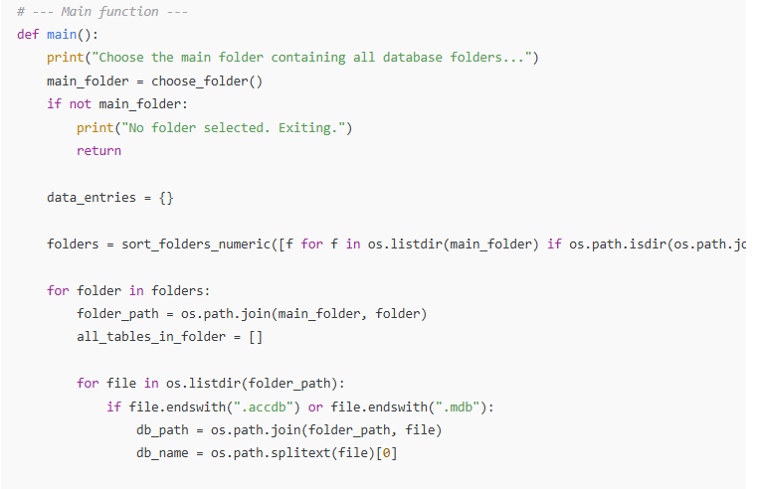
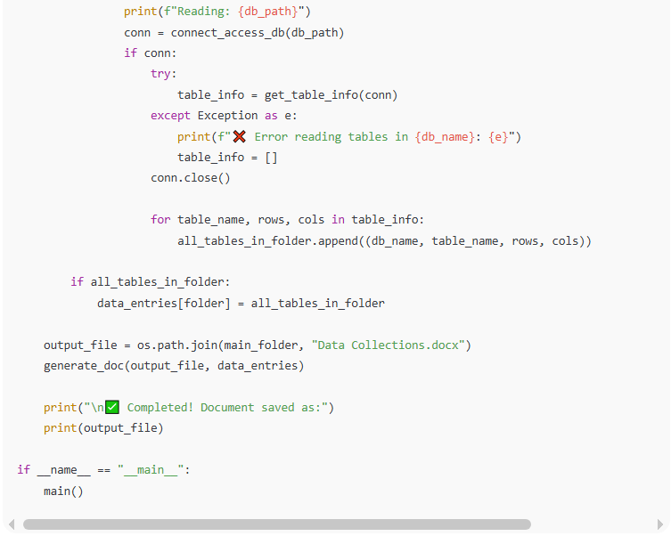
import os
import re
import pyodbc
from docx import Document
from docx.shared import Pt
from tkinter import Tk, filedialog, simpledialog

# --- Folder selection ---
def choose_folder():
Tk().withdraw()
folder_path = filedialog.askdirectory(title="Select Main Folder Containing Database Folders")
return folder_path

# --- Connect to Access DB with optional password ---
def connect_access_db(db_path):
while True:
try:
conn_str = (
r"DRIVER={Microsoft Access Driver (*.mdb, *.accdb)};"
f"DBQ={db_path};"
)
conn = pyodbc.connect(conn_str, autocommit=True)
return conn
except pyodbc.Error as e:
# Check if password required
error_msg = str(e)
if "Not a valid password" in error_msg:
# Ask for password via Tkinter popup
Tk().withdraw()
password = simpledialog.askstring(
"Database Password",
f"Enter password for database:\n{db_path}\nLeave blank to skip:",
show="*"
)
if not password:
print(f"Skipping {db_path} due to missing password.")
return None
try:
conn_str = (
r"DRIVER={Microsoft Access Driver (*.mdb, *.accdb)};"
f"DBQ={db_path};"
f"PWD={password};"
)
conn = pyodbc.connect(conn_str, autocommit=True)
return conn
except Exception as e2:
print(f"❌ Could not connect with password: {e2}")
# Loop again to ask password
else:
print(f"❌ Could not connect to {db_path}: {e}")
return None

# --- Get table names from DB ---
def get_table_names(cursor):
table_names = []

try:
cursor.execute(
"SELECT Name FROM MSysObjects "
"WHERE Type = 1 AND Flags = 0 AND Name NOT LIKE 'MSys%'"
)
table_names = [row[0] for row in cursor.fetchall()]
except:
pass

if not table_names:
try:
for row in cursor.tables(tableType='TABLE'):
name = row.table_name
if not name.startswith("MSys"):
table_names.append(name)
except:
pass

filtered = []
for name in table_names:
if name.startswith("~TMP") or "TMPCLP" in name.upper():
continue
filtered.append(name)

return filtered

# --- Get table info ---
def get_table_info(connection):
cursor = connection.cursor()
tables = []

table_names = get_table_names(cursor)

for table_name in table_names:
try:
row_count = cursor.execute(f"SELECT COUNT(*) FROM [{table_name}]").fetchone()[0]
except:
row_count = 0

try:
cursor.execute(f"SELECT * FROM [{table_name}] WHERE 1=0")
col_count = len(cursor.description)
except:
col_count = 0

tables.append((table_name, row_count, col_count))

return tables

# --- Shorten long names ---
def shorten_name(name, max_length):
if len(name) <= max_length:
return name
part_len = max_length // 2 - 2
return name[:part_len] + "..." + name[-part_len:]

# --- Generate Word document ---
def generate_doc(output_path, data_entries):
doc = Document()

# Main heading
doc.add_heading("Data Collections", level=1)

# Calculate totals
total_tables = total_rows = total_cols = 0
for folder_tables in data_entries.values():
for _, _, rows, cols in folder_tables:
total_tables += 1
total_rows += rows
total_cols += cols

# Summary
summary_lines = [
f"Total Tables: {total_tables}",
f"Total Rows: {total_rows}",
f"Total Columns: {total_cols}"
]
for line in summary_lines:
p = doc.add_paragraph(line)
p.bold = True

doc.add_paragraph("\n")

# Folder-wise details
for folder_name, folder_tables in data_entries.items():
doc.add_heading(f"{folder_name}", level=2)

for db_name, table_name, rows, cols in folder_tables:
full_text = (
f"Data Path: {folder_name} Folder -> {db_name} Database -> "
f"{table_name} Table [Rows x Columns: {rows} x {cols}]"
)

# Adjust font size
if len(full_text) >= 116:
font_size = 7
elif len(full_text) >= 104:
font_size = 8
elif len(full_text) >= 96:
font_size = 9
else:
font_size = 10

p = doc.add_paragraph()
parts = [
("Data Path: ", True),
(f"{folder_name} Folder -> ", False),
(f"{db_name} Database -> ", False),
(f"{table_name} Table ", True),
(f"[Rows x Columns: ", True),
(f"{rows} x {cols}", False),
("]", True)
]
for text, bold in parts:
run = p.add_run(text)
run.bold = bold
run.font.size = Pt(font_size)

doc.add_paragraph("\n")

doc.save(output_path)

# --- Numeric sort ---
def sort_folders_numeric(folders):
def extract_number(name):
match = re.match(r'(\d+)', name)
return int(match.group(1)) if match else float('inf')
return sorted(folders, key=extract_number)

# --- Main function ---
def main():
print("Choose the main folder containing all database folders...")
main_folder = choose_folder()
if not main_folder:
print("No folder selected. Exiting.")
return

data_entries = {}

folders = sort_folders_numeric([f for f in os.listdir(main_folder) if os.path.isdir(os.path.join(main_folder, f))])

for folder in folders:
folder_path = os.path.join(main_folder, folder)
all_tables_in_folder = []

for file in os.listdir(folder_path):
if file.endswith(".accdb") or file.endswith(".mdb"):
db_path = os.path.join(folder_path, file)
db_name = os.path.splitext(file)[0]

print(f"Reading: {db_path}")
conn = connect_access_db(db_path)
if conn:
try:
table_info = get_table_info(conn)
except Exception as e:
print(f"❌ Error reading tables in {db_name}: {e}")
table_info = []
conn.close()

for table_name, rows, cols in table_info:
all_tables_in_folder.append((db_name, table_name, rows, cols))

if all_tables_in_folder:
data_entries[folder] = all_tables_in_folder

output_file = os.path.join(main_folder, "Data Collections.docx")
generate_doc(output_file, data_entries)

print("\n✅ Completed! Document saved as:")
print(output_file)

if __name__ == "__main__":
main()

This code assumes you have:
- pyodbc installed: pip install pyodbc
- python-docx installed: pip install python-docx
- Microsoft Access driver installed on Windows.

You want rows where every column is empty except the ID to not be counted in the row total.
That row has:
- empty strings → ❌
- zeros → ❌
- no real data → ❌

new get_table_info()
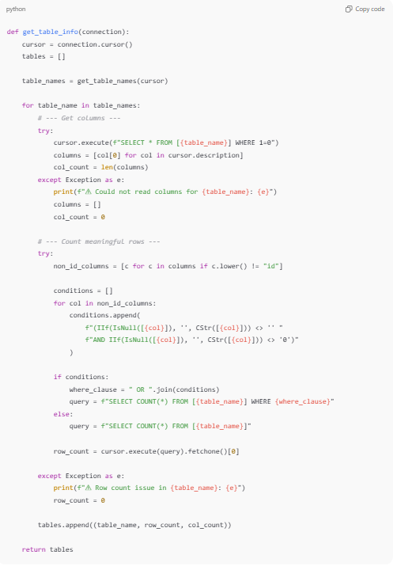
def get_table_info(connection):
cursor = connection.cursor()
tables = []

table_names = get_table_names(cursor)

for table_name in table_names:
# --- Get columns ---
try:
cursor.execute(f"SELECT * FROM [{table_name}] WHERE 1=0")
columns = [col[0] for col in cursor.description]
col_count = len(columns)
except Exception as e:
print(f"⚠ Could not read columns for {table_name}: {e}")
columns = []
col_count = 0

# --- Count meaningful rows ---
try:
non_id_columns = [c for c in columns if c.lower() != "id"]

conditions = []
for col in non_id_columns:
conditions.append(
f"(IIf(IsNull([{col}]), '', CStr([{col}])) <> '' "
f"AND IIf(IsNull([{col}]), '', CStr([{col}])) <> '0')"
)

if conditions:
where_clause = " OR ".join(conditions)
query = f"SELECT COUNT(*) FROM [{table_name}] WHERE {where_clause}"
else:
query = f"SELECT COUNT(*) FROM [{table_name}]"

row_count = cursor.execute(query).fetchone()[0]

except Exception as e:
print(f"⚠ Row count issue in {table_name}: {e}")
row_count = 0

tables.append((table_name, row_count, col_count))

return tables

